**GREP ASSIGNMENT**

**Mandatory:**

**1. Use any .c file. Using grep command extract and display**

**a. all lines beginning with #include with line numbers**

**b. display all lines which do not begin with #include**

**c. display the line number of main()**

**d. extract all lines containing characters of opening and closing parathesis {(,))**

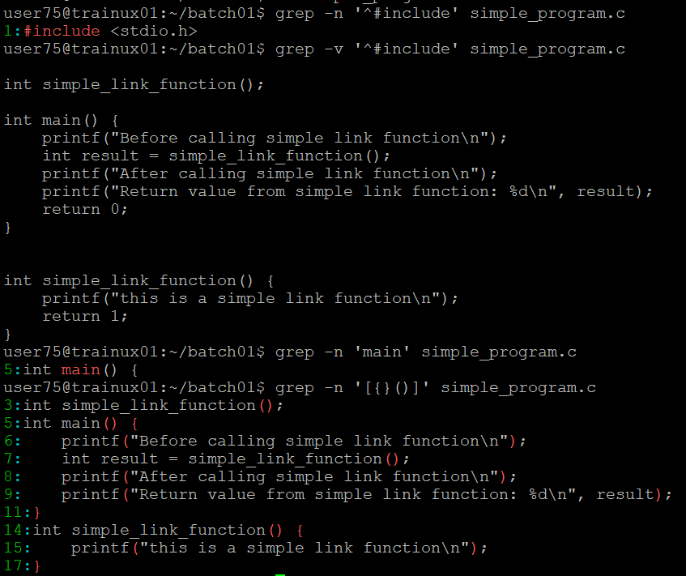

**2. Perform the above operations on a set of *.c files**



